**Exercise 1: Configuring a Basic Spring Application**

**File : pom.xml**

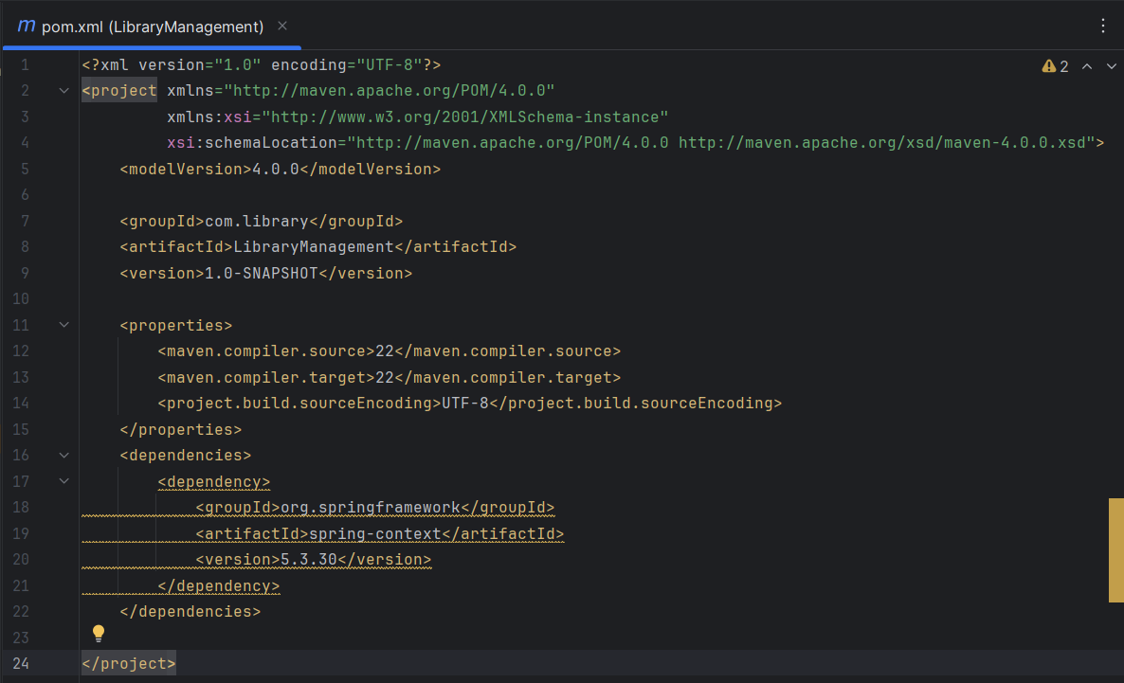

File:applicationContext.xml

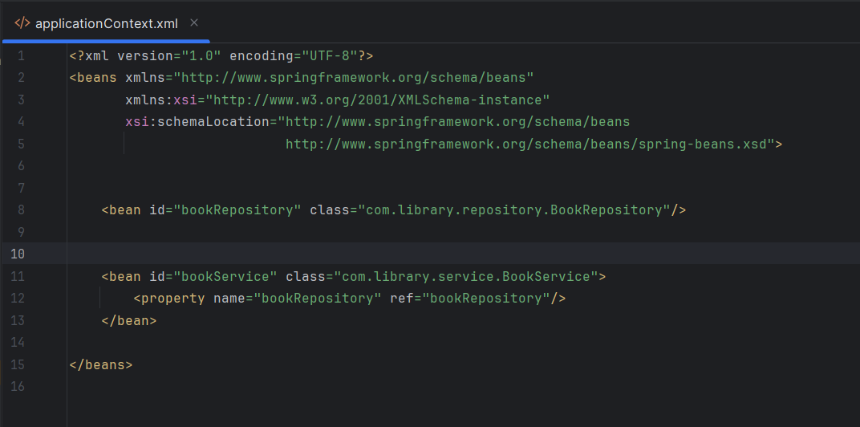

File:BookRepository.java

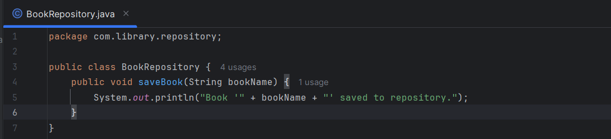

File:BookService.java

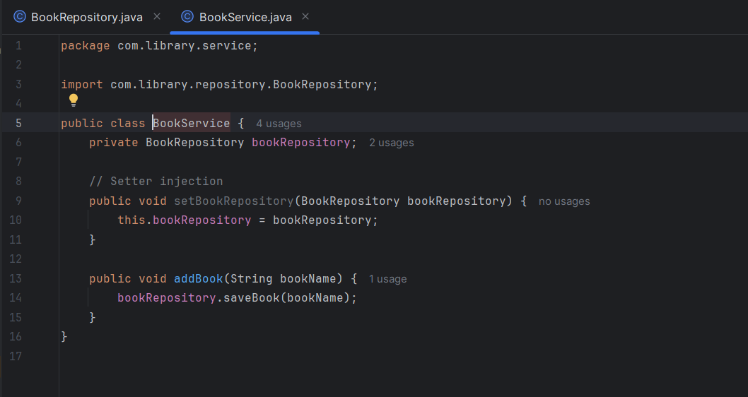

File:MainApp.java

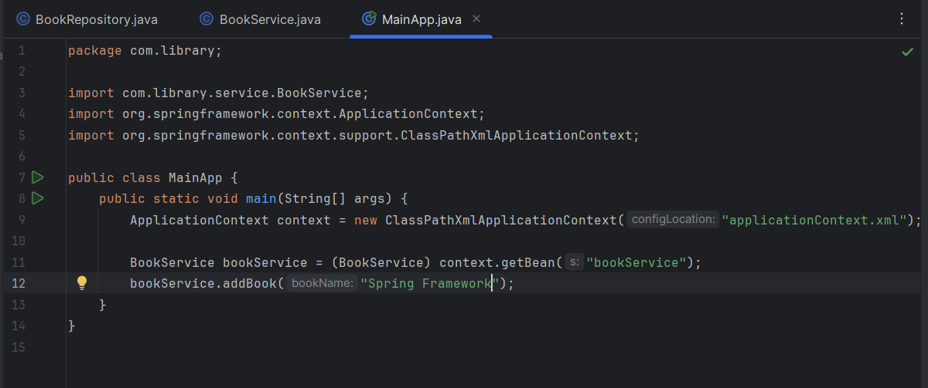

OUTPUT:

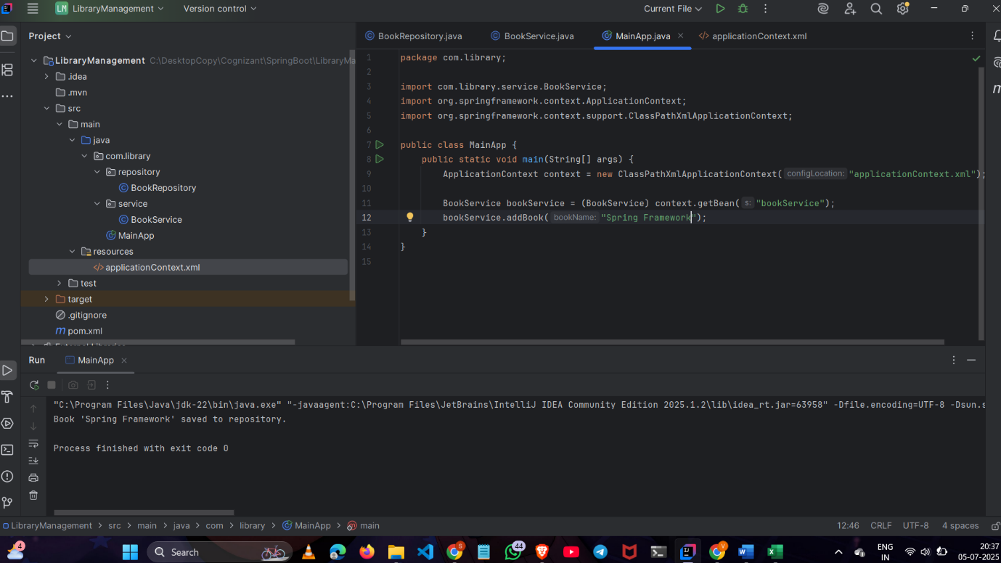

**Exercise 2: Implementing Dependency Injection**

File: applicationContext.xml



File: BookService.java



OUTPUT:



**Exercise 4: Creating and Configuring a Maven Project**

File :pom.xml

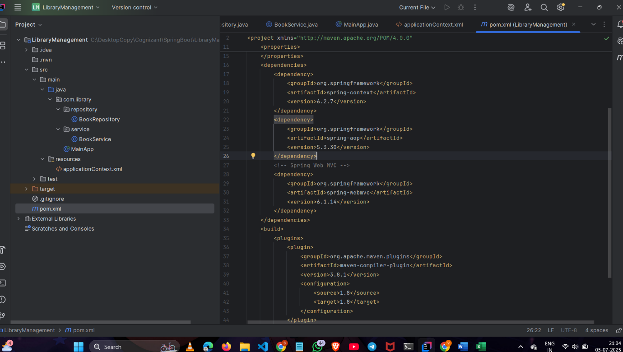

**Exercise 5: Configuring the Spring IoC Container**

OUTPUT:



**Exercise 7: Implementing Constructor and Setter Injection**

File : applicationContext.xml

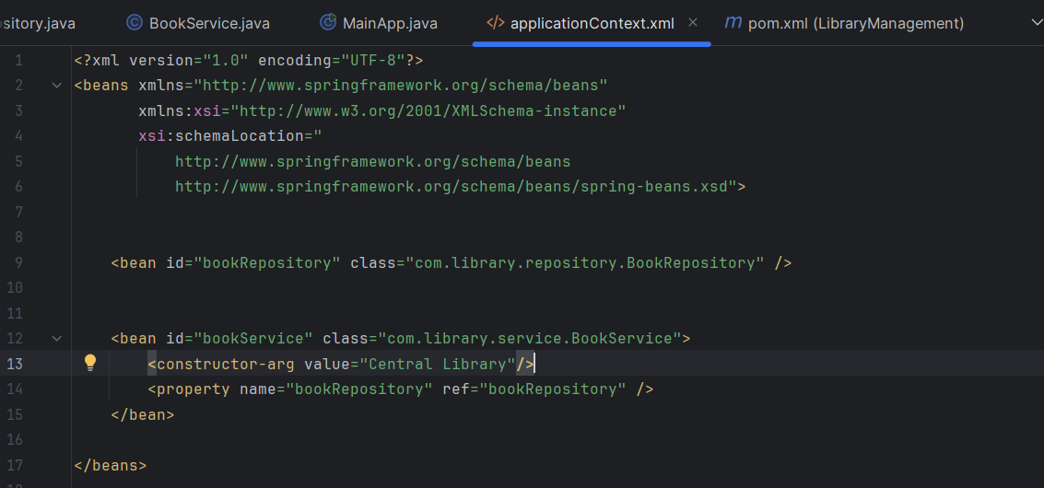

File: BookService.java

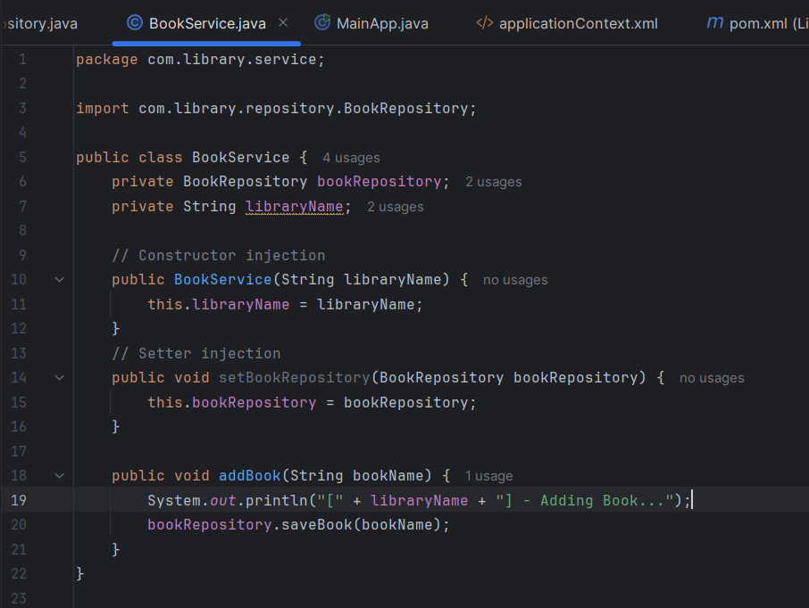

OUTPUT:

